Page URL - https://rootcabs.com/support
Slug Suggestion - https://rootcabs.com/support

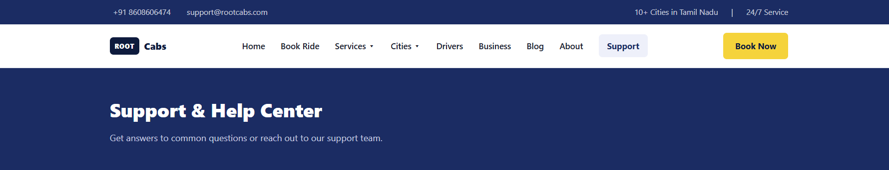

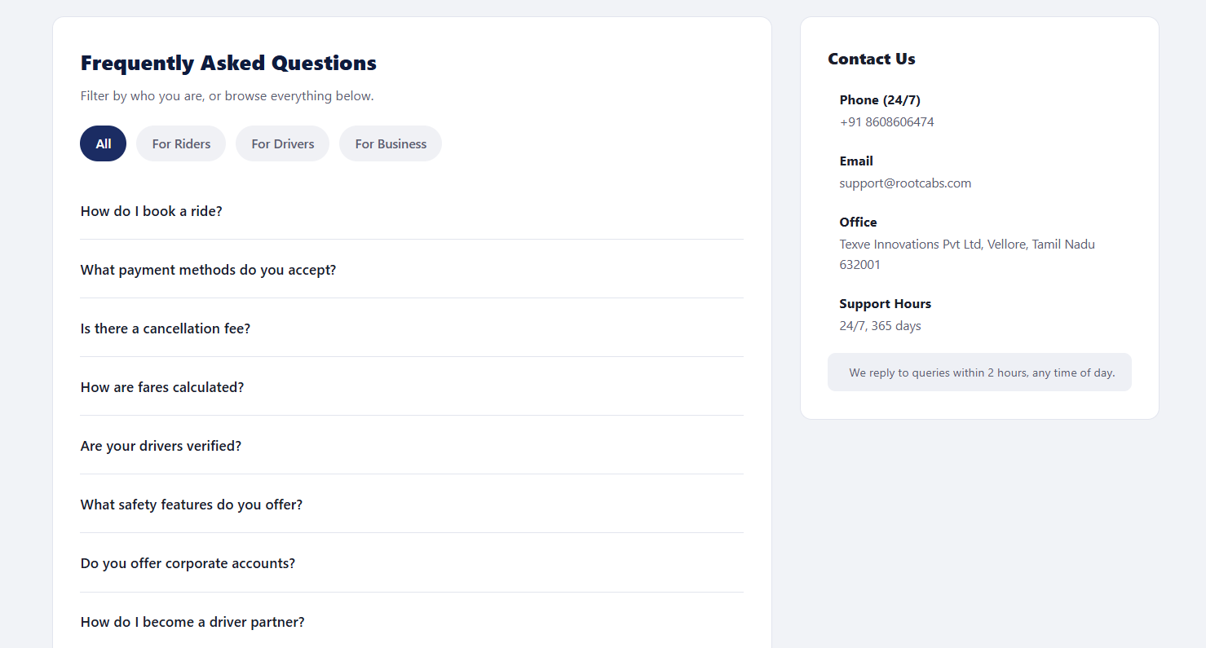

Please remove the do you offer corporate accounts questions
My driver hasn't arrived yet what should I do?
The driver asked to cancel and rebook outside the app — is that allowed?
I was charged more than the fare shown at booking — why?
Do you charge extra for tolls, parking, or waiting time?
How does the SOS button work?
What happens if there's an accident during my ride?
Can I share my live trip location with a family member?
I left something in the cab — how do I get it back?
How do I file a complaint about a driver?
Why was my driver account temporarily suspended?
How do I check my daily payout status?
I want a refund for a cancelled ride — how long does it take?

